NOW OR NEVER|| version 1.0

|  |  |  |  |
| --- | --- | --- | --- |
| version | Made by | Reviewd by | Reviewed date |
| 1.0 | Shreyanshi Singh Distwar  Anmol Kumar Mourya |  | 18-june 2019 |

Content:-

1. Overview
2. Modules
3. Academics
   1. Introduction
   2. Workflow address
4. Practice
   1. Topics
   2. Levels
   3. Questions
5. IDE (code, compile and run) API
   1. Text area
   2. Language compiler
   3. Test cases
6. Contests
   1. Information about other site contests
   2. Contests organised on this site
7. Transaction API
8. Contact us
9. Search bar
10. Discussion
11. Login/signup
12. Profile
13. DBMS
    1. User records login/signup
    2. Questions table
    3. User-question table mapping

Overview

Now or Never

This is a learning platform for the ones who are eager to dive into the ocean of technology and find out the jewels out of that.

A platform which aim for overall personality development. We don’t want you to always follow others’ lead but to encourage you to lead so that others can follow you. We will not only enhance your technical skills but will make you learn about teamwork, working under pressure, aptitude, projects, and a lot more with back of your friends.

Each and every one of you matters. Mentors personally look after each and everyone through daily sheet tracking along with focusing on increasing your productivity, checking your health status and managing time and schedule. Since all of you will be part of all the meetings and sessions, therefore no decision will be made without everyone’s approval. There is a provision of shuffling of batches based on your credits, performance and level of knowledge improved.

We offer non trivial opportunities like free certification coupons, certification preparation, paid courses of areas you want to explore, etc. at no upfront cost. You can take offs depending on the seriousness of the situation and can complete your task once you are back.

We aim to fulfill all your expectations and demands. We will prepare you for aptitude test, puzzles, psychometric test, group discussions, interviews, hackathons, make you learn CS subjects, prepare reports, resumes, projects and every other single thing which in any way will aid your development.

**Happy Coding**

Here is the work flow of the product. Each modules and there working is described further.

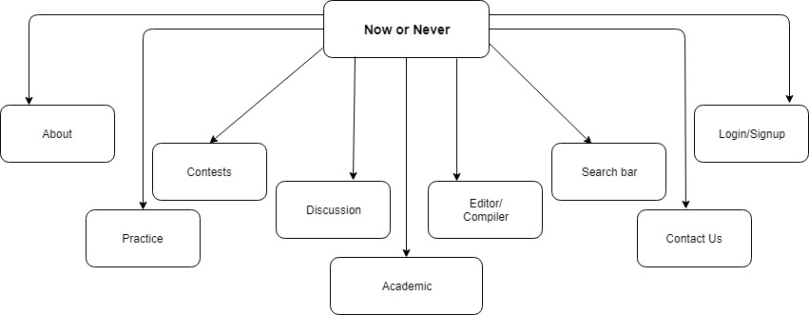

MODULES

ACADEMICS:-

Practice

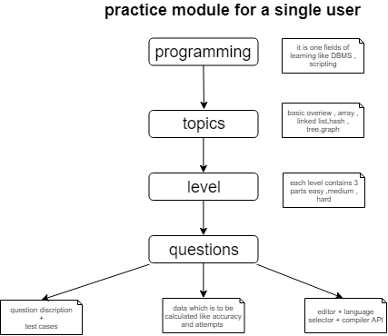

Along with programming other technical modules related to interview will be included in this part like DBMS,MOCK INTERVIEWS, aptitude,core CSE subjects, Personality development, puzzles,etc.

Programming

The programming part will contain topics related to interview like

1. Basic overview
2. Maths
3. Array
4. Searching
5. Strings
6. Bit manipulation
7. sorting
8. Linked list
9. Stack and queue
10. Backtracking
11. Hashing
12. Heaps and maps
13. Tree
14. Dynamic programming
15. Greedy algorithm
16. Graphs

These topics will further be divided into parts (Easy,Medium & Hard) including EXPERT level

IDE (Code,Compile and Run)

IDE will be based on online API along with language selector along user input field. This IDE will be available for normal user too which will help everyone to run and check their code

Transaction API

This transaction API will help for transactions related to a course will manage the receipts and details

LOGIN/SIGNUP

It is the part where the user can create account for gaining other features of the platform. User will need mail ID for creating an account along with mail verification

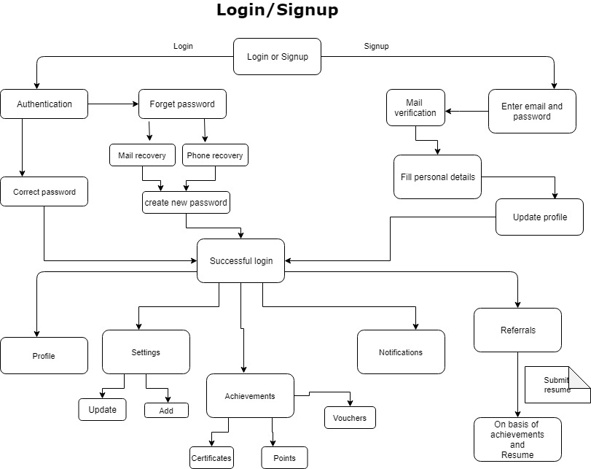

PROFILE

